Vertex connect table of the blend
How to create this table:
- Get blend from a FamilyInstance.
- Get the Top Sketch and Bottom Sketch of the blend.
- Get the Faces and Edges of the blend.
- After geometric comparison we can get the vertices and figure out the vertex connect table.

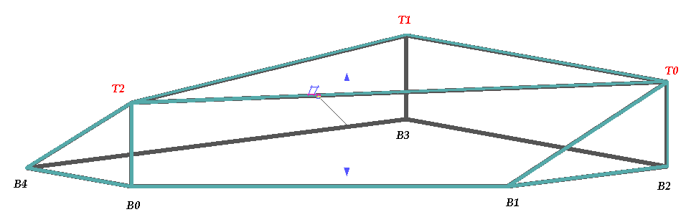
Index | First(Bottom) | Second(Top)
1 | 0 | 2
2 | 1 | 0
3 | 2 | 0
4 | 3 | 1
5 | 4 | 2

